Project Design Phase-II
Data Flow Diagram & User Stories

Date | 11 July 2026
Team ID | N/A
Project Name | STOCK TRADING APP
Maximum Marks | 4 Marks

Data Flow Diagrams:
Project Data Flow Diagram (Level 0)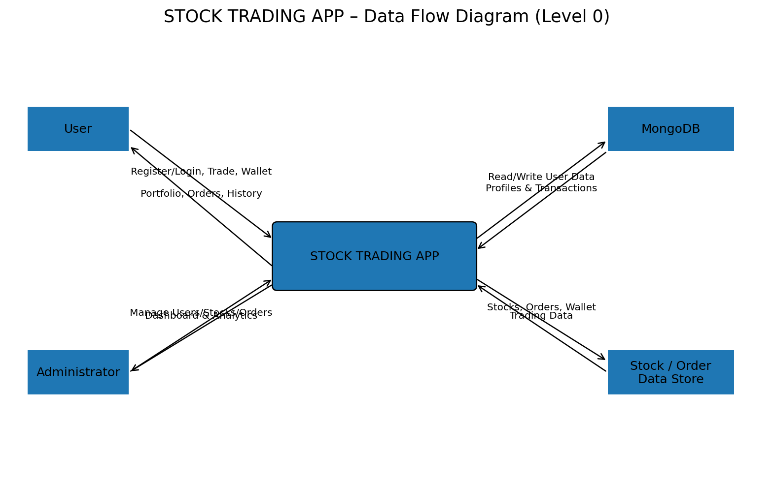
A Data Flow Diagram (DFD) is a traditional visual representation of the information flows within a system. A neat and clear DFD can depict the right amount of the system requirement graphically. It shows how data enters and leaves the system, what changes the information, and where data is stored.
Example: DFD Level 0 (Industry Standard)
Example: (Simplified)
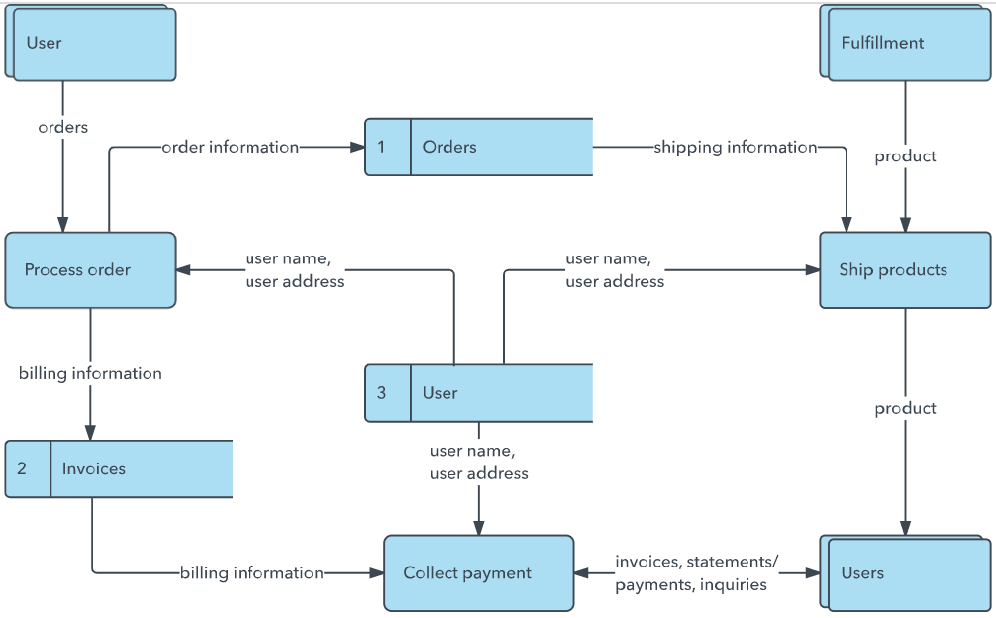


User Stories
Use the below template to list all the user stories for the product.
User Type | Functional Requirement (Epic) | User Story Number | User Story / Task | Acceptance criteria | Priority | Release
User (Web user) | Project Architecture | USN-1 | As a project user, I can access a technically structured MERN application with clearly defined user and admin flows. | The application follows a clear client-server-database architecture and supports defined user/admin roles. | High | Sprint-1
User (Web user) | Project Architecture | USN-2 | As a user, I can navigate through the application using an organized frontend flow. | Core pages and routes are accessible through the application navigation. | High | Sprint-1
Administrator | Project Architecture | USN-3 | As an administrator, I can access role-specific administrative features. | Admin-only pages and management functions are separated from normal user functions. | Medium | Sprint-1
Developer | Project Setup and Configuration | USN-4 | As a developer, I can run the React/Vite client with required dependencies. | Frontend starts successfully using npm run dev. | High | Sprint-1
Developer | Project Setup and Configuration | USN-5 | As a developer, I can run the Node.js and Express backend server. | Backend starts successfully and exposes REST API routes. | High | Sprint-1
Developer | Project Setup and Configuration | USN-6 | As a developer, I can configure environment variables for MongoDB, JWT and server port. | Application reads configuration securely from the server environment file. | High | Sprint-1
User (Web user) | Backend Development | USN-7 | As a user, I can register and log in securely. | Valid credentials create/authenticate an account and JWT is used for protected access. | High | Sprint-2
User (Web user) | Backend Development | USN-8 | As an authenticated user, I can access and manage my profile. | Protected profile data is returned only for an authenticated user. | High | Sprint-2
User (Web user) | Backend Development | USN-9 | As a user, I can buy and sell available stocks. | Valid trade requests create/update orders and portfolio holdings. | High | Sprint-2
User (Web user) | Database Development | USN-10 | As a user, I can have my account and trading information stored persistently. | MongoDB stores user, stock, order, portfolio and transaction-related data. | High | Sprint-2
Developer | Database Development | USN-11 | As a developer, I can connect the backend to MongoDB using Mongoose. | The server establishes a successful MongoDB connection. | High | Sprint-2
Administrator | Database Development | USN-12 | As an administrator, I can manage application records through defined models. | Schemas support required user, stock and order management operations. | Medium | Sprint-2
User (Web user) | Frontend Development | USN-13 | As a new user, I can register and log in through responsive frontend pages. | Registration and login forms communicate successfully with backend APIs. | High | Sprint-3
User (Web user) | Frontend Development | USN-14 | As a user, I can view stocks and interactive stock charts. | Stock information and chart data are displayed in the user interface. | High | Sprint-3
User (Web user) | Frontend Development | USN-15 | As a user, I can view my portfolio, orders, transaction history and wallet activity. | The corresponding pages display the user's trading and wallet information. | High | Sprint-3
Administrator | Frontend Development | USN-16 | As an administrator, I can use a dashboard to manage users, stocks and orders. | Admin dashboard provides management views and supported add/edit/delete operations. | High | Sprint-3
User (Web user) | Project Execution | USN-17 | As a user, I can use the integrated application from frontend to backend. | Major user workflows operate with frontend, backend and database connected. | High | Sprint-4
Tester / Reviewer | Project Execution | USN-18 | As a reviewer, I can verify application functionality through output screenshots and demonstrations. | Major user and admin outputs are documented and demonstrated. | Medium | Sprint-4
Reviewer | Project Execution | USN-19 | As a reviewer, I can access project code and supporting demo deliverables. | GitHub repository, README and demo resources are prepared and accessible for review. | High | Sprint-4

